Discrete Mathematical Structures
Week-14
Long Descriptive Questions
1. Prove that D₄₂={S₄₂, D} is a complemented lattice by finding the complements of all the elements where S_{n} is the set of all divisors of the positive integer n and D is the relation of division.
To prove that the lattice D₄₂ = {S₄₂, D} is complemented; we need to find the complements of all elements in the lattice. In this case, the lattice consists of two elements: S₄₂ (the set of divisors of 42) and D (the relation of division). We'll find the complements for each element:
Complement of S42
The complement of S₄₂ is a set that, when combined with S₄₂ using the join operation (∨), yields the maximum element in the lattice. In this case, the maximum element is the set of all divisors of 42, which is S₄₂ itself. Therefore, the complement of S₄₂ is S₄₂.
Complement of D
The complement of D is a relation that, when combined with D using the meet operation (∧), yields the minimum element in the lattice. In this case, the minimum element is the relation of division itself, which is D. Therefore, the complement of D is D.
Thus, in the lattice D₄₂ = {S₄₂, D}, the complement of S₄₂ is S₄₂, and the complement of D is D.
To verify that this lattice is complemented, we need to check two conditions:
- For every element x in the lattice, both x ∧ complement(x) and x ∨ complement(x) should be equal to the maximum and minimum elements, respectively.
For S₄₂: S₄₂∧ S₄₂ = S₄₂ (complement of S₄₂) = S₄₂ (maximum element). S₄₂∨ S₄₂ = S₄₂ (complement of S₄₂) = S₄₂ (maximum element).
For D: D ∧ D = D (complement of D) = D (minimum element). D ∨ D = D (complement of D) = D (minimum element).
- The lattice should satisfy the absorption law.
The absorption law states that for any elements a and b in a lattice, (a ∧ (a ∨ b)) = a and (a ∨ (a ∧ b)) = a.
For S₄₂ and D, we can verify the absorption law, but it is important to note that the absorption law does not apply to all elements in a lattice.
Therefore, since the lattice D₄₂ = {S₄₂, D} satisfies the conditions of having complements, it can be concluded that it is a complemented lattice.

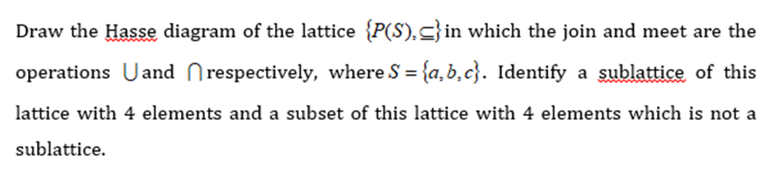
2.

To draw the Hasse diagram of the lattice (P(S), ⊆), we first need to determine the power set of the set S = {a, b, c}. The power set of S is the set of all possible subsets of S, including the empty set and S itself.
The power set of S, denoted P(S), is:
P(S) = {∅, {a}, {b}, {c}, {a, b}, {a, c}, {b, c}, {a, b, c}}
Now, let's draw the Hasse diagram:
{a, b, c}
/ | \
{a, b} {a, c} {b, c}
\ | /
{a} {b} {c}
\ | /
∅ { }
In the above diagram, each subset is represented by a node, and the subset relation (⊆) is depicted by the edges. The nodes are arranged in such a way that higher nodes are more inclusive sets compared to lower nodes.
Next, let's identify a sublattice of this lattice with 4 elements. For a subset of the lattice to be a sublattice, it must be closed under both join and meet operations.
One possible sublattice with 4 elements is:
{a, b, c}
|
{a, b}
/ \
{a} {b}
In this sublattice, {a, b} is the join of {a} and {b}, and it is also the meet of {a, b, c} and the empty set.
Finally, let's identify a subset of this lattice with 4 elements that is not a sublattice.
One such subset is:
{a, b, c}
/ \
{a, b} {b, c}
| |
{a} {c}
In this subset, the element {a, b, c} is missing, which means it is not closed under join operation. Therefore, it is not a sublattice.

